Wireless Power Monitor

Group 2: Alex Demos, Amir Shahnami, Frank Ladolcetta, Manuel Rodriguez

School of Electrical Engineering and Computer Science, University of Central Florida, Orlando, Florida, 32816-2450

Abstract --- Two different devices being used; one central unit and three power sensing units. Communication between all devices will be done through XBee communications. Each power sensing device will have a power sensor, an ATmega 168, an XBee radio chip, and a relay. The head unit will have an ATmega 168 microcontroller, an XBee radio and an LCD screen. The power sensor’s XBee will tell the head unit’s XBee how much power its device is consuming and then through the ATmega 168, the LCD will display the monetary value of the power consumption. The head unit can also shut off any of the power sensor’s devices.
Index Terms --- Interconnected power systems, Microcontrollers, Optical Isolator, Power measurement, Radio communication

I. Introduction
The premise of this project is having a way to measure the consumption of electricity of home electrical devices. This measurement should be in dollars and cents based on power consumption. The idea would be to measure the power on every electrical device in the house and wirelessly send this information to a head unit that will display the information gathered. Using this information, the consumption of the device in dollars per hour, week, month and year would be calculated.
Saving energy has always been the desire of anyone that has to pay a utility bill. Sometimes in an attempt to save money people will go to all kinds of lengths such as turning off lights, only turning on the water heater whenever they take a shower, keeping the home temperature as high as possible, etc. Taking these measures can be useful but there is no sure way of knowing how much is being saved or if the sacrifices are worth the effort. With a scientific way to monitor power usage in the house, it will be clear to know exactly how much each appliance is consuming per pay period.
The design and construction of a power meter for the household is the goal of this project. The power bill is one of the highest household expenses and anything that can make it lower is definitely welcome. The power meter can be used to measure the power consumption of any electrical device in the home that is connected with the use of a plug. The device will be connected to the power meter which in turn will be connected to the household outlet. It will then display the calculated power consumption per hour, day or month. The results will be display in a dollar amount. The information gathered by the power meter will be transmitted wirelessly to a head unit that will have an LCD display.
The goal for the project is to have an accurate measurement of power. Commercial meters have an accuracy ranging from 2% to over 10%. The goal here is to have an accuracy of at least 5%. The range of the wireless transmission should be no less than 30 feet and for that reason, the Zigbee wireless protocol will be used. The meter should be affordable so it will be built as inexpensively as possible while still maintaining the accuracy goals. It will also consume as little power as possible as that is obviously one of the goals of a consumer using it.
Energy usage is not only a personal problem but also a worldwide problem. The resources in the planet are not infinite. It is necessary to make sure to not burn the candle at both ends. Saving energy is not only a good way to save money but it is also a way to make sure that future generations will be able to have the energy necessary to live in the conditions presently available in the United States.
Preserving the planet’s resources will have an impact for generations to come. If each person keeps track of their energy usage and makes an effort to use less energy, they will be contributing to a more abundant future in this world. The environment will also benefit if less energy is consumed. Energy production creates pollution so the less of it that is needed or used by consumers, the less polluted the planet will be. A home energy measuring system and what can be learned from it will not only benefit people in general but also their children and the ecosystem.

II. Component Selection
Four main components done into two devices, the power sensor units and the head unit are the make-up of the project. The four components are the LCD screen for just the head unit to display the power consumption, XBee radio chips in all the devices for the communication between the devices, an ATmega 168 microcontroller in the head unit to be the brains for the LCD screen and to send commands and receive information to the XBee in the head unit, and also, a relay switch with the power sensor in each of the power sensing units so when the command for the head unit is sent to turn off a certain power sensing unit, it has the capabilities to shut off any of the devices which have their power consumption being monitored.

A. XBee communications
The wireless transceiver the group decided to use was the XBee OEM RF 802.15.4 as shown in figure 1. The range was good enough for the group having a max range of 100ft (30m). While 250kbps might seem small for a commercial product, for a simple project like the power units with the central unit, it will be sufficient to work properly. For the project, since it consists of a central unit and multiple power units scattered through a house and, for experimental sake, the group will purchase one for the central unit and three because the experiment will consist of three units scattered through the house, which would run up the price to $76.00 total for just the radio chips.

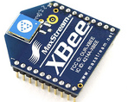
Figure 1- XBee chip from Sparkfun Electronics

After weeks of research, trying to find a good adapter for the XBee, an adapter from Adafruit was the one chosen costing $10 per unit. Once constructed, the adapter kit will look like figure 2, shown below. The kit includes a 3.3V regulator board, a level shifting chip that drops the input voltage that is 5V and drops it to 3.3V, activity LED, a power LED, pins to represent ten of the most useful pins and 20 pin holes to place the XBee in.
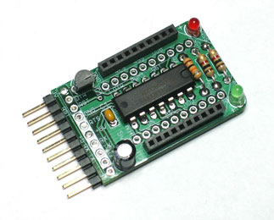
Figure 2- XBee adapter kit without the XBee chip from Ladyada.net

B. Power relay
One of the features of the power meter is the ability to switch the component being measured on and off. The user can do this by going to the head unit and pressing a certain button. The main concern in choosing a relay is having it rated to handle the kind of current and voltage that will be measured. For this reason the Sharp S216S02 solid state relay will be used. This relay is optically isolated and rated for 240 VAC and 16 A. The relay will be installed in series with the components A/C line.

C. LCD Screen
Displayed below in figure 3, is an image of a 4 x 20 character LCD that is of the same type that will be used in the project design. The image below shows a small variety of the types of symbols that can be displayed by using this type of an LCD screen, and gives the reader a rough idea as to what a potential output could look like.

Figure 3: LCD Screen with permission of Robot Room
D. Microcontroller
When the project began, the microcontroller was going to be an Arduino Mega but then it changed to the ATmega 168, shown below in figure 4, to make the project more challenging. The ATmega 168 is a simpler microcontroller than the typical Arduino.
Atmel's ATMega168 is an 8-Bit Processor in 28 pin DIP package. There are 23 I/O lines, six of which are used in a 10-bit ADC. This runs up to 20MHz with external crystal.
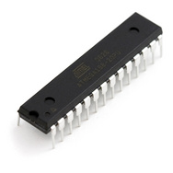
Figure 4: Picture of ATmega 168 from Sparkfun Electronics

IV. Schematic
A. XBee Radio Chips
As stated above, our means of communications for this project was through using XBee radio chips. The pin configuration can be seen below in figure X. Even though all 20 pins, with the pin layout shown in figure 5, have significant purposes, in this project, the group has six in use and only used four of the six pins. The six significant pins in use are the ground pin (pin 10), clear-to-send flow control (pin 12), request-to-send flow control (pin 16), VCC that is set to 5V (pin 1), the receive pin (pin 2) and the transmit (pin 3). Of the six, as stated above, four were used at all times, which are the ground pin, the receive pin, the transmit pin and the VCC pin.
Figure 5: Pin Layout for the XBee from Sparkfun Electronics
Figure 6 illustrates the schematic of the XBee adapter. This allows the XBee to be easily programmed using a cord that connects to the important six pins stated above and any computer. X-CTU was the program used to program the XBee radio chips. This allows you to manipulate the chips for things like sleep time, baud rate and giving it a network ID so only other XBees with the same network ID can communicate to each other. Also, this allows for a basic test to see if the chip responds to basic commands, but the most important feature is the range test. The range test is crucial because this uses one XBee to send out information and have the other XBee, which is hooked up elsewhere, to receive that data and have it sent back to make sure the two, three or however many desired, act as transceivers, which is a key part of this project because all radio chips will be receiving and transmitting information.
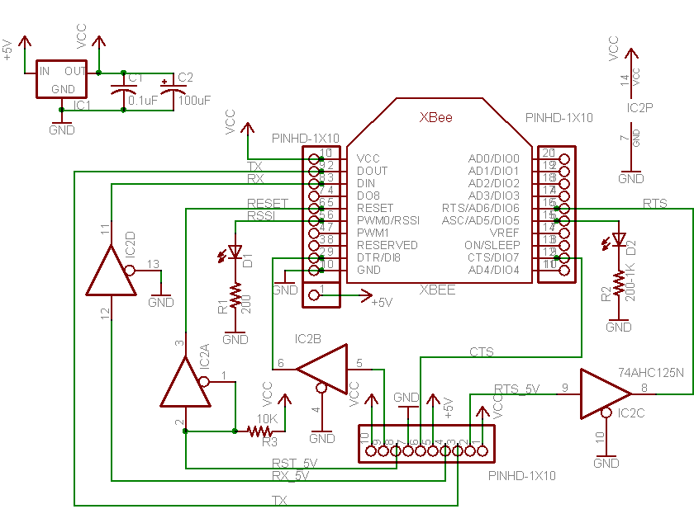
Figure 6: schematic of the XBee adapter kit from ladyada.com

B. Relay/Power Sensor
The figure below in figure 7 is a general schematic of what the sensor used in the project.
Figure 7: General Sensor Schematic with permission from Microchip.com

To install the meter, all that is needed is for the sensor to be connected to an outlet and the appliance to be measured. When it is in calibration mode, it will be connected only to a computer via the serial interface. In order to program the meter it must be connected to a computer using the In System Programming interface or ISP for short. For the safety of the meter and computer, opt couplers can be used to isolate the meter from the high voltages and currents of the analog side. An opt coupler uses a short optical transmission path to transfer an electric signal from a transmitter and a receiver but it keeps them isolated from each other. It is an integrated circuit that prevents the analog signals to destroy the digital components of the design. The electric signal is converted to a light signal that is then again converted to an electric signal keeping the two sides from affecting each other. When the meter is connected to the high voltage lines it is vital that care is taken if a computer is connected to it. The reason for this is that the meter has no galvanic isolation from the high current main lines. Since the meter and the computer would both be connected to ground and live wires, the computer could cause a short. In essence, the computer serves as a short between ground and the live wires and the destruction of the computer but be all but guaranteed.

C. ATmega 168
The ATmega 168 is a 20-pin microcontroller that is used in this project. The pin configuration can be seen below in figure 8. The operating voltage for the device to 1.8V - 5.5V. The voltages and frequency are closely related, where while the device is running between 0-4 MHz, the voltage is between 1.8v-5.5v. While the frequency is from 0 to 10 MHz, the voltage is between 2.7 - 5.5.V, and when the frequency is between 0 to 20 MHz, the voltage range is 4.5 - 5.5V
The ATmega168 has very unique features such as having a power-on reset and a programmable brown-out detection, an internal calibrated oscillator, external and internal interrupt sources. There are 23 programmable I/O lines. The operating temperature range from -40°C to 85°C. The current in active mode is 0.2 mA and the power-down mode is 0.1 μA. [1]
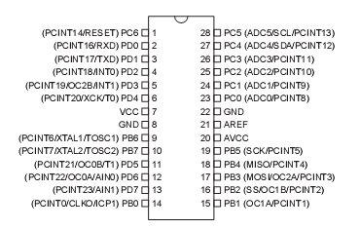
Figure 8: Pin Layout for the ATmega168 from Arduino.cc

V. Block Diagram
A. LCD Screen
The following figure below is the block diagram for the plans set up to operate the group’s LCD screen. As portrayed in figure 9, the power sensor first sends its collected data wirelessly to the microcontroller on the group’s main receiver device. At which point, the main microcontroller will calculate the power consumption cost of the particular device that the sensor was reading, and store the data for the calculation of monthly accumulated power consumption. Then the calculated power costs of the appliance being measure will be sent to the microcontroller for processing. The microcontroller then puts the data measured through coding to select what bits will represent the needed information. These bits will be sent through the data pins on the LCD’s HD44780 microcontroller. The HD44780 microcontroller is then instructed to output the character by the microcontroller at a specific location, which then outputs the data to the LCD screen.

Figure 9: Block Diagram of the LCD Screen

B. Relay/Switch block diagram
The design will need a relay switch to turn off and on power to any desired measured device. Figure 10 shows the basic block diagram of how the relay switch will be implemented.
Figure 10: Block Diagram of the Relay in the Power Sensor

The wireless receiver will wait until it receives a signal from the main unit’s wireless transmitter to turn off a specific device. Once that signal has been received by the sensing unit’s microcontroller, it will change a digital logic output pin. This relay, and circuit, will remain like this until the sensing unit’s wireless receiver gets another signal from the main unit’s wireless transmitter. Once the sensing unit’s microcontroller detects another signal, it will trigger the output pin that controls the relay switch and reengage the voltage supply to the device to be measured.
For the following figure, figure 11, shows a basic block diagram of how the power meter works. It shows the basic functions of the power meter sensor. The sensor takes the voltage and current measurement from the wall outlet, the microprocessor takes those measurements and calculates power and the information is sent through the transceiver over to the main unit. Another detail of the diagram is the power relay. The power relay will be used to turn the appliance on and off.

Figure 11: Power Meter Block Diagram

C. XBee Radio Chips
In figure 12, the flow chart illustrates how information is received and transmitted through an XBee chip.
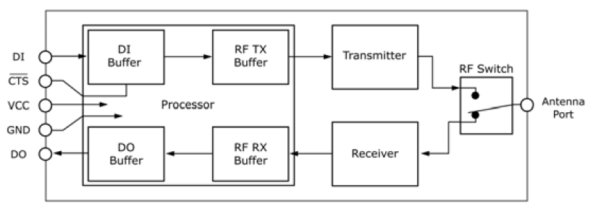
Figure 12: Block Diagram of the Basic Communication Flow of an XBee from XBee Product Manual

When information comes in from either another XBee chip or from the power sensor, it goes through pin 3 (DI) and when the information is processed, and needs to be sent out to either another XBee chip or from the power sensor, it will go through pin 2 (DO). When information is sent in through pin 3, the data is stored in the RF TX Buffer, which is the box to the left of the DI Buffer. Once the data is processed, it goes though the transmitter and flows down the diagram with the switch going from the top to the bottom, eventually sending out the information to whichever device it is supposed to be sent to.

D. Up/Down Push Buttons
What this block diagram shows, in figure 13, is that when the user pushes the up or down arrow button, a switch is pulled sending a pin high within the microcontroller. This high pin then gets sent through the “C” code within the microcontroller which produces a change within the data so that the microcontroller can continue its course of changing the listed devices being measured.

Figure 13: Block diagram of an up/down pushbutton

The change in the data to be displayed gets sent through the microcontroller to the character LCD screen in the form of a different listing of devices.
On both the main unit and the sensing units‟ printed circuit boards, the microcontrollers and wireless components will all be on preassembled printed circuit boards. Because of this, the circuit board will need to be designed in one of two ways. These components can be set on “plugs” to allow a slight clearance over the rest of the printed circuit board and potentially avoid any difficult spacing or these components can strategically placed to avoid any spacing issues that may be caused from other components on the printed circuit board.
E. Power On/Off Push Buttons
The block diagram shown below in figure 14 is an illustration of the power on/off switch on the main receiving unit. This button is used to turn off the power supplied to the appliance that is being measure by the selected device from the list. As displayed below, when the user pushes the button similar to what was discussed before, a switch is pulled sending a voltage through the connected pin of the microcontroller. The microcontroller then sends this data through the “C” code of the power off push button, which instructs the microcontroller to either turn on or off the supplied power of the selected device. It does this by sending the data through the transceiver into the specific sensor, in turn, that will then flip the relay, removing supplied power from the device being monitored.

Figure 14: Power on/off Pushbutton

VI. Putting it all together
A. PCB Main Unit
The LCD screen with the push buttons shown below in figure 15 was a preliminary test the group have where it was receiving the data from three different power sensors through XBee radio chips and displaying its values on the screen. Once completed, the LCD screen will display one device at a time with its power consumption in monetary value and its status in the case of having it turned on or off. The two buttons on the right help scroll from one unit to another. Pressing the button to the right of the red button allow the device to work after one sets the kW/h rate.

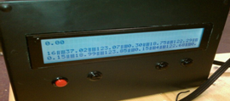
Figure 15: Main Units LCD display with buttons
This microcontroller will handle all information inputted by both the sensors and the user. The user will be using push buttons to enter any variable changes. These push buttons will also be implemented to scroll through all currently connected and transmitting sensing devices. As well, the push buttons will be utilized to engaged and disengage power to the currently measured device of any of the transmitting sensing devices. In order to prevent potential false readings of push buttons, both software and hardware debouncing will be implemented on the push buttons through delays, interrupts, and analog circuit filters. The wireless communications will be done with XBee modules. These modules will be with Arduino XBee shields to assist with interfacing between the two devices. The XBees were chosen because of their peer-to-peer and transceiver capabilities. The design will also utilize a 40 character by 4 line LCD screen provided by New Haven International. This LCD display will adequately show enough information to both show information gathered by the sensors, as well as show multiple, live sensors, rather than a single sensor at a time. All devices within the main unit will run strictly off battery power. This is done to prevent substantial power consumption added to a home from the design itself.

B. PCB Sensor Unit
Below in figure 16, is what the power sensor looks like. The two plugs going in and out of the box are to plug into the wall and the device being measured. In this device, there is a relay, a power sensor and an XBee.
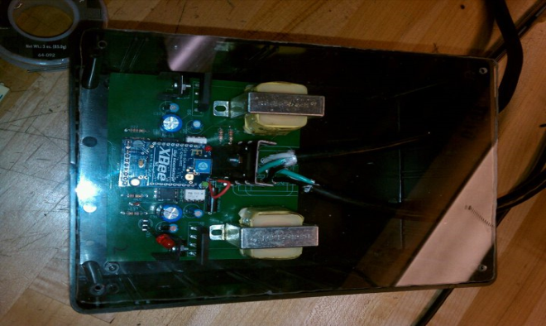
Figure 16: The Inside of the Power Sensor
The ATmega 168 microcontrollers will handle all incoming values from the sensing devices. These devices will consist of both voltage and current sensors to give an accurate power consumed from each measured device. These readings will then pass through a low pass filter to prevent any random spikes in values to affect the overall outcome of the sensors. All wireless communications will be handled with the XBee transceivers. These transceivers will also have the Xbee adapter kit attached for easier interfacing between the two devices. The ATmega 168 microcontroller will have control over a relay switch which it will turn off and on as it receives the appropriate signal from the main unit’s microcontroller. An externally visible LED will also be attached to the sensing units to easily display whether a measured device is currently having power transmitted to it or if it the circuit has been temporarily opened. The LED will act as a visible connectivity, it will be on when the circuit is closed and the measured device has power and it will be off when the circuit is disengaged. The sensing units will run on wall power, as they will already be attached to the power supply and should not consume a substantial amount of power. As well, the power consumed by the sensing units should be known. This is to aid in power consumed calculations in the central unit’s logic and to be displayed on the LCD screen.

VII. Conclusion
The more aware people become of the importance of saving energy, the more common this type of power meter will become. Power meters might become the PC of the future. Every home will have one. Just as there are fuel gauges in a car, there could be this type of fuel “gauge” for the house. As more people realize the type of savings that they can accomplish individually and as a whole, the more common this type of device will become. The power bill of the future will not be a monthly surprise as it is now.

VIII. Sources
[1] “Atmel Products – AVR Solutions – Atmega168PA” <http://www.atmel.com/dyn/products/product_card.asp?PN=ATmega168PA>
[2] “Arduino” 23 February 2010
<http://arduino.cc/>
[3] “XBee Product Manual” 3 June 2010
<http://ssdl.stanford.edu/ssdl/images/stories/AA236/0708A/Lab/Rover/Parts/xbeeproproductmanual.pdf>
[4] AVR 28 Pin 20MHz 16K 6A/D - ATMega168 “SparkFun Electronics” 3 June 2010
<http://www.sparkfun.com/commerce/product_info.php?products_id=7957>
[5] Cook, David. "Robot Room – Making Printed Circuit Boards." PCB - Copper Printed Circuit Boards. Robot Room, n.d. Web. 28 Apr 2010. <http://www.robotroom.com/PCB.html>.
[5] Cliff, Jao. Xi Guo. “Power Box: The Safe AC Power Meter” Web 25 April <http://instruct1.cit.cornell.edu/courses/ee476/FinalProjects/s2008/cj72_xg37/cj72_xg37/index.html>

IX. Biographies on Each of the Group Members

Frank Ladolcetta:
Frank Ladolcetta is currently pursuing his Bachelor’s Degree and is in his senior year in Electrical Engineering at the University of Central Florida. He is currently an intern at Lockheed Martin Missiles and Fire Control plant, which he obtained through UCF’s college work experience program. He was offered, and has accepted a position as an Applications Engineer in the Engineering Leadership Program, at National Instruments in Austin, Texas. He currently plans on starting work in Austin in September, shortly after graduation.

Manuel Rodriguez:

Manuel Rodriguez is a senior Electrical Engineering student at the University of Central Florida. He got an Associate in Arts at Seminole Community College. He currently lives in Altamonte Springs, FL and expects to find an electrical engineering job upon graduation.

Alex Demos:

Alex Demos is a senior Electrical Engineering student at the University of Central Florida. He is currently interning at Lockheed Martin's Missiles and Fire Control through the UCF College Work Experience Program. He plans on pursuing his Master's Degree in Electrical Engineering with a focus on optics coming up this following fall term.

Amir Shahnami:

Amir Shahnami is a senior Electrical Engineering student at the University of Central Florida. He is currently interning with ACD Telecom, a telecom firm that deals with public safety agencies, and has worked there for the past six years. After obtaining his Electrical Engineering Degree, he is planning on going to law school in the Washington D.C. area to become a lawyer within the engineering field.

